Ideas / inspiration

When discussing 2D video games, their design, devolvement and studio’s ability to overcome limitations, it has hard not to included Nintendo’s contribution with the likes of Zelda and Mario. Two franchises still around today.

When discussing with our team, we all showed interested in puzzle games. With the skills and knowledge that we have gained through this course and our assignment 1, we thought that we had a good foundation for building a *dungeon crawling Zelda* like game.

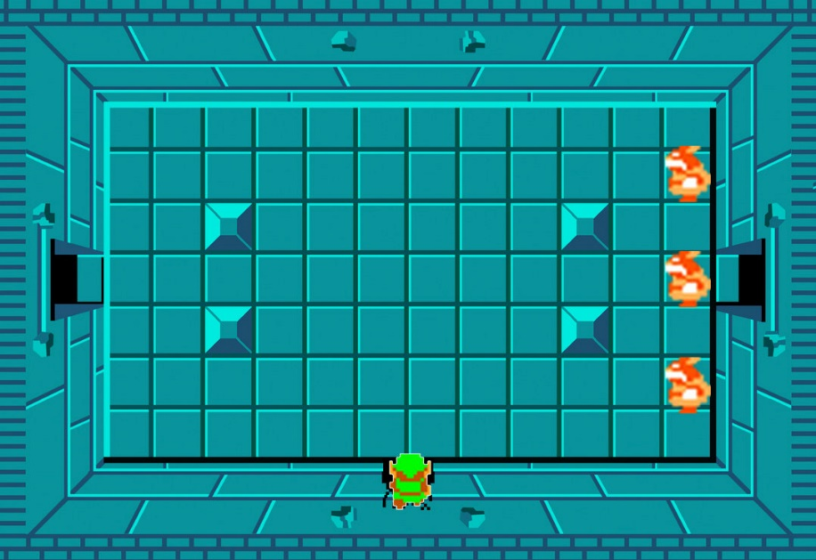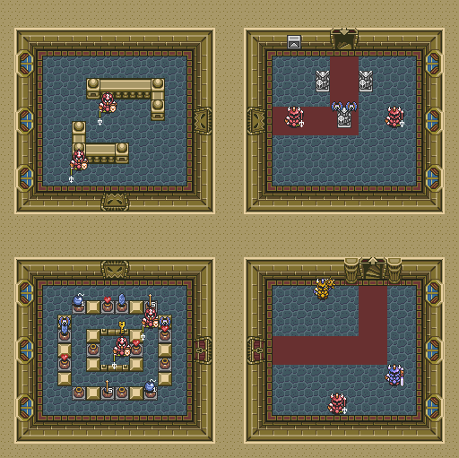The room-based puzzles of Zelda’s dungeons were the source of inspiration for us to build a game, that has players complete grid-based maze puzzles to procced to the next level.

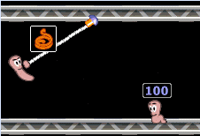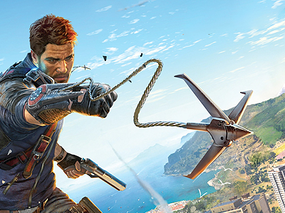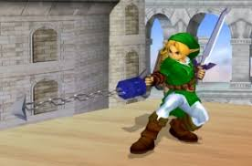To enhance the game and the player’s experience, we wanted to add an ability that improved the players simple grid-based movement. To achieve this, we decided to give the player a grappling hook ability. Not only does this make the player’s movements more enjoyable, but it also allowed us to develop the level / maze design around this ability.

Game Design

With the key ideas of a rooms, where the player needs to navigate a maze, using standard movement and a grappling ability, we were able to start working on the game design.

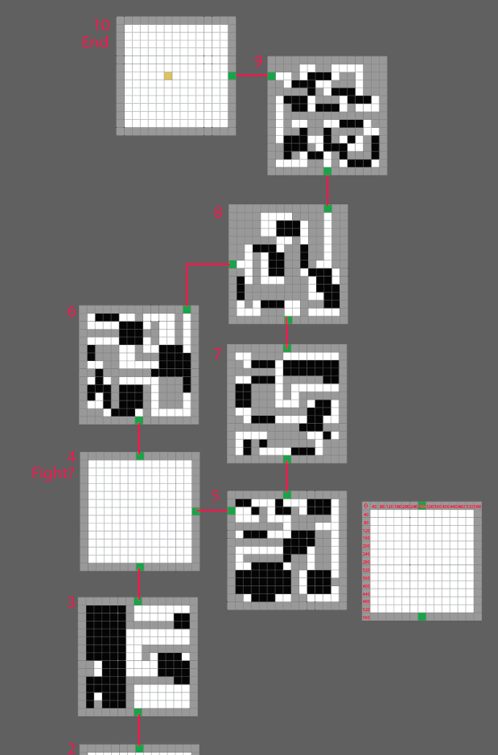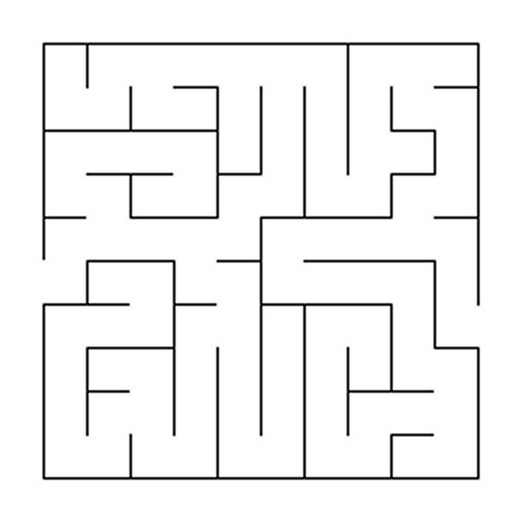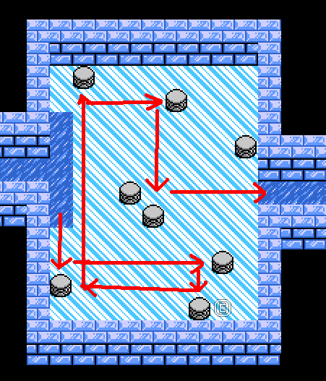This started with researching different maze ideas and applying this knowledge to our game’s mechanic. From here we were able to start to design each room’s layout and make sure the maze and game play fitted together.

To merry the maze style and grappling ability together, we used a ground hazard in which the player would need to traverse with their grabbling ability in order to continue. Rules were placed on the grappling ability in order to define what was achievable for the player while using the ability. This then helped us fine tune the room design.

To add to the difficulty of some of the rooms, additional treasure chest are placed as optional tasks for the player. Solving how to collect these, while also finding how to complete the level betters the player’s score.

Game Features

* 10 unique dungeons to solve
* 2 boss fights
* Treasures to collect to increase score
* 2 player mode, where players race to see who can complete the rooms the fastest with the best score
* Read your character’s thoughts as they collect items and battle enemies
* Collect plants to add health
* Suspensive music and immersive sound effects.
* Character / boss and item animations

Code and Feature Discussion

1. Non-linear game progression. Example: In level 4 we have two doors that lead to different levels. This is makes the game more non-linear. This can be made more complex by adding multiple doors in each level. May be hiddden easter egg level..etc.
2. NPC AI has patrol, seek, wait states. More states in state machines can be added and more variety of state machines can be added. We have 3 state machines: NPC enemy, NPC follower, BGC (background character) follower / wonderer. There are parameters in state machine classes that tunes the behaviour via reaction time: how long to make a decision during each state. Increasing the reaction time makes the character slower and less agile. Possible improvements outside scope of this project: Introduce cruizing state for flying terror that goes around in path of large circle, mimc flying behaviours. Add routing algorithms, currently the NPC calculates shortest Euclidean distance and not considering path blocked by obstacle, so npc can get stuck from time to time.
3. Friendly NPC can make random comments and reactions. Comments are from chat GPT. Each ChatGPT request runs on a different thread, no penalty on performance. The comments are made when the NPC state machine state changes or if the NPC health / score increase or decrease. There is also an idle timer, so NPC will say something every couple of seconds. This is made more random by adding random number generator to decide to speak or not when comment timer is up. We can make it more realistic by introducing more comment types. We have about 5 comment types to make remarks on different situations. If ChatGPT fails, there is a backup comment dictionary in the code.

Comment speech bubble and score notifications are displayed beside the character on the screen in descending order. They follow the character.

1. The use of Linked List / Array List / Queues as a means of communication for in-game events. There are Audio Queue, Animation Queue, Elimination Queue, Spawn queue. In-game object raises requests to these queues to be processed by game engine to play audio / animation at certain location and time, due to in-game events. These queues decouples the classes.
2. World builder class: we can easily control addition of different types of objects in each level.
3. Level class: Embodies a level. Returns a list of exits / entry doors. Contains a link to the next level object. Paints screen with details.
4. Collision detection logic is a bit messy as it happens in two places rather than one. One in the in-game objects themself, another at the world level. This can be improved.
5. The classes are designed to support dependency injection, we can adopt a DI framework but its out of scope. Eg: State Machine all inherit IStateMachine interface and can be injected from DI or factory classes depending on the NPC class type.
6. Grid design makes the movement not smooth enough. We can add smoothing to character / NPC movements.
7. Bouncing ball projectile, explodes when runs out of energy.
8. Smoke animation.
9. We have three theme music, played at different level.
10. 3 types of game: Single / double / quest (Hardest).
11. NPC character generation - the NPC characters in the end game levels are randomly generated. We can randomly generate quest character as well if we have enough time.
12. Quest characters follows closet players in quest, can jump with hookshot, tracks a score..
13. Consumable items like coins / vegetable cabbages / bombs are generated randomly. Improvements can be made such that they spawn on walkable area only. They could spawn inside walls and become inaccessible.

Group Member’s Contributions

In alphabetical order:

**Bryce:**

* level layout design.
* Level layout coding.
* Menu design.
* Boss fights design.
* Documentations.
* General bug fixes.
* Play testing.

**Helen:**

* Game design and ideas.
* Story ideas
* Play testing.

**Jerry:**

* Game software architecture design, core classes and base game functionalities.
* Animations, audio and sound.
* Game object interactions / collisions / scores.
* NPC dialogues / Chat GPT / notifications.
* Game AI designs.
* GitHub repository setup and integration of code from team members.
* Bug fixes.
* Play testing.

**Josh:**

* Game design and ideas.
* Grapple mechanism and design.
* Play testing.

About the Game:

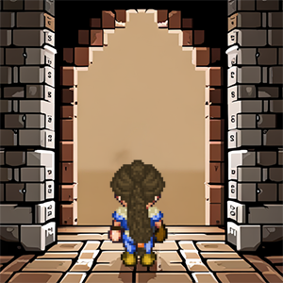In a realm shrouded in mystery, Lidia, a brave and determined heroine, embarks on a perilous journey. Drawn by the allure of hidden treasures and ancient secrets, she fearlessly enters the dungeons. Empowered by the legendary "hookshot," a grappling hook that fused to her arm, Lidia defies danger and navigates treacherous terrain. With each triumph over enemies and the acquisition of precious loot, she inches closer to the ultimate prize. Driven by unwavering bravery, Lidia's quest for glory unfolds as she unravels the depths of the dungeons, leaving an indelible mark upon the annals of Eldoria's history.

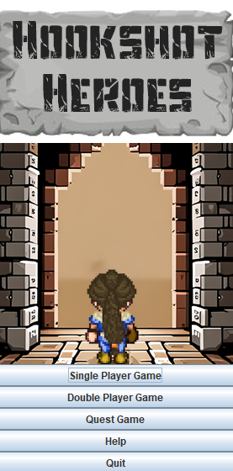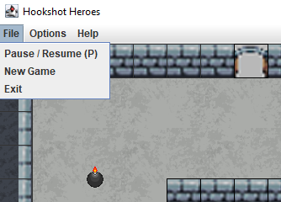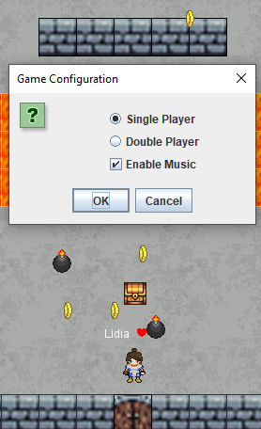 Interactive Menus:

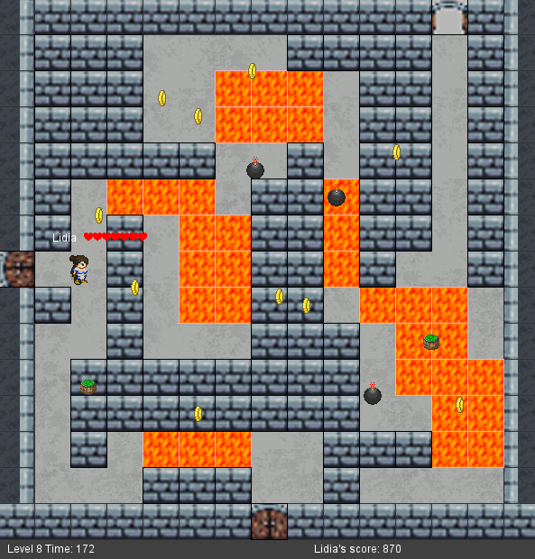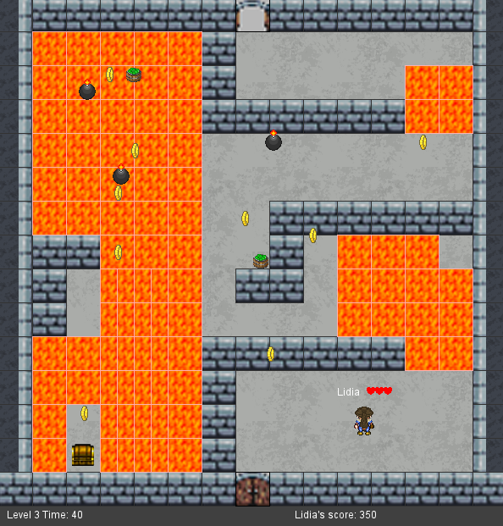Navigate 10 unique dungeons!

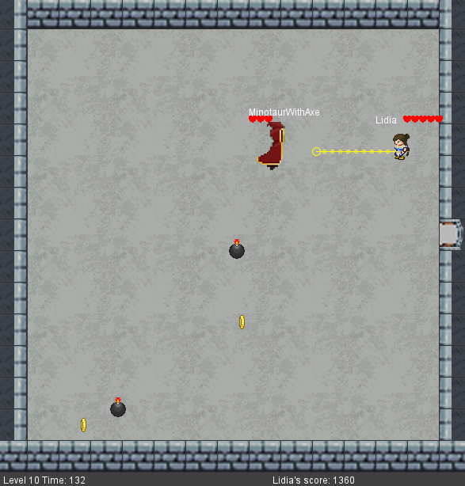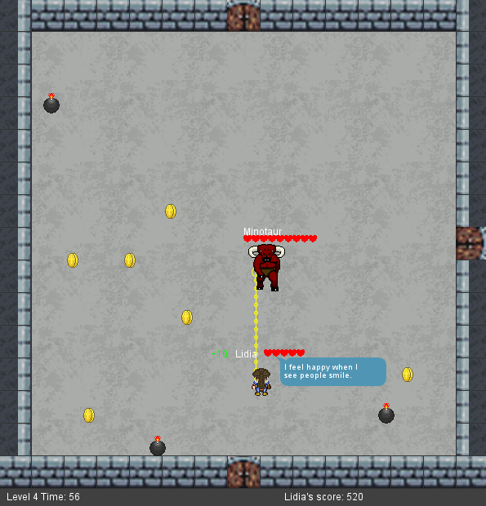Two unique boss fights:

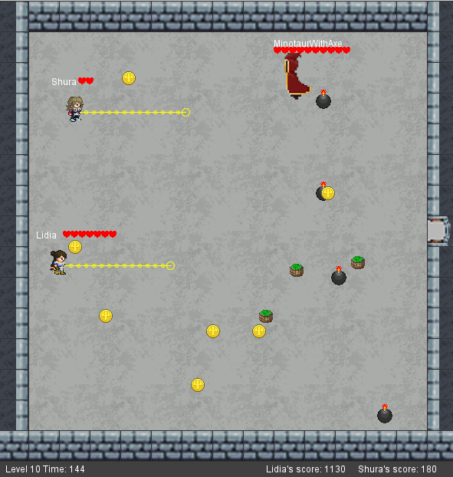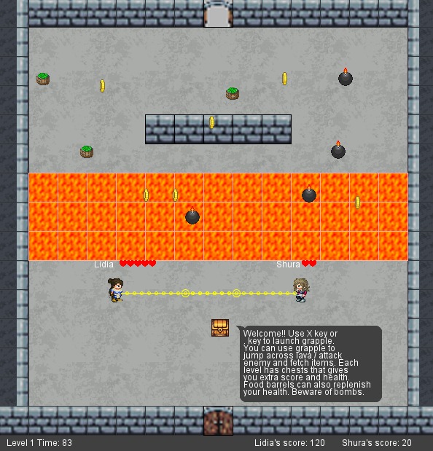Two Player Mode:

AntumDeluge. (2017). Barrel Sprites [Digital image]. OpenGameArt. Retrieved from <https://opengameart.org/content/barrels-mage-city-arcanos-remix>

bluecarrot16. (2018). LPC Medieval Village Decorations [Digital image]. OpenGameArt. Retrieved from <https://opengameart.org/content/lpc-medieval-village-decorations>

bluecarrot16. (2018). LPC Terrains [Digital image]. OpenGameArt. Retrieved from <https://opengameart.org/content/lpc-terrains>

Bryce. (2023). Floor Sprite [Digital image].

Bryce. (2023). Main Image [Digital image].

davesch. (2014). Lava Sprite [Digital image]. OpenGameArt. Retrieved from <https://opengameart.org/content/16x16-and-animated-lava-tile-45-frames>

Danimal. (2021). Flying Terror [Digital image]. OpenGameArt. Retrieved from <https://opengameart.org/content/flying-terror>

diamonddmgirl. (2016). Edited and Extended 24x32 Character Pack [Digital image]. OpenGameArt. Retrieved from <https://opengameart.org/content/edited-and-extended-24x32-character-pack>

Fesliyan, D. (2016). Scarey Atmospheres Ch 2. [Audio file]. Retrieved from <https://www.fesliyanstudios.com/royalty-free-music/download/scarey-atmospheres-ch-2/163>

Gaming Sound FX. (2021). Coin Sound Effect [Audio file]. Retrieved from <https://www.youtube.com/watch?v=mQSmVZU5EL4>

IndigoFenix. (2019). Bomb Sprite [Digital image]. OpenGameArt. Retrieved from <https://opengameart.org/content/bomb-2>

jalastram. (2014). Monster Sounds [Audio files]. OpenGameArt. Retrieved from <https://opengameart.org/content/monster-and-creatures-sound-effects-pack-001> <https://opengameart.org/content/monster-sound-tutorial>

K0huro. (2022). Mage Sprite Sheet [Digital image]. Reddit. Retrieved from <https://www.reddit.com/r/PixelArt/comments/raaip5/an_8_directional_sprite_of_a_mage_for_a_game_of/>

Leonard Pabin. (2012). Avalon Sprite [Digital image]. OpenGameArt. Retrieved from <https://opengameart.org/content/whispers-of-avalon-archer-sprite>

morgan3d. (2013). Coin Sprite [Digital image]. OpenGameArt. Retrieved from <https://opengameart.org/content/spinning-gold-coin>

Redshrike. (2011). Castle Interior Sprites [Digital image]. OpenGameArt. Retrieved from <https://opengameart.org/content/rpg-indoor-tileset-expansion-1>

Redshrike. (2011). Indoor RPG Tileset [Digital image]. OpenGameArt. Retrieved from <https://opengameart.org/content/16x16-indoor-rpg-tileset-the-baseline>

Reemax. (2019). Whip Sound Effect [Audio file]. OpenGameArt. Retrieved from <https://opengameart.org/content/whip-sound>

Siegmund, D. (2011). Dungeon Wall Sprite Sheet [Digital image]. OpenGameArt. Retrieved from <https://opengameart.org/content/16x16-pixel-art-dungeon-wall-and-cobblestone-floor-tiles>

StarNinjas. (2021). Crunch Sound Effect [Audio file]. OpenGameArt. Retrieved from <https://opengameart.org/content/7-eating-crunches>

Unnamed. (2016). Explosion Sound Effect [Audio file]. OpenGameArt. Retrieved from <https://opengameart.org/content/9-explosion-sounds>

Wolfgang_. (2017). Boss Music [Audio file]. OpenGameArt. Retrieved from <https://opengameart.org/content/lava-area-theme>

Yamilian. (2012). Lidia Sprite Sheet [Digital image]. OpenGameArt. Retrieved from <https://opengameart.org/content/lpc-heroine>

Yamilian. (2012). Shura Sprite Sheet [Digital image]. OpenGameArt. Retrieved from <https://opengameart.org/content/lpc-heroine-2>

ZaPaper. (2014). Animated Water and Waterfalls [Digital image]. OpenGameArt. Retrieved from <https://opengameart.org/content/lpc-animated-water-and-waterfalls>

Zabin. (2013). RPG Tiles - Cobble Stone Paths, Town Objects [Digital image]. OpenGameArt. Retrieved from <https://opengameart.org/content/rpg-tiles-cobble-stone-paths-town-objects>